POLITICAL JAGGERNAUTS: A QUANTITATIVE ANALYSIS OF CANDIDATES IN THE 2019 LOK SABHA ELECTION

1.INTRODUCTION

The Lok Sabha is composed of representatives of people chosen by direct election on the basis of Universal Adult Suffrage. The Constitution of India allows for a maximum of 550 members in the House, with 530 members representing the States and 20 representing the Union Territories. The 17th Lok Sabha was formed by the members elected inn the 2019 Indian general election. Elections, all across India, were conducted in seven phases from 11th April 2019 to 19th May 2019 by the Election Commission of India

The Bharatiya Janata Party received 37.36% of the vote, the highest vote share by a political party since the 1989 general election, and won 303 seats, further increasing its substantial majority. In addition, the BJP-led National Democratic Alliance (NDA) won 353 seats.

* 1. OVERVIEW

In this report we gone through the analysis of candidates in the Lok Sabha Election which is held in 2019 under the following topics:

* General votes
* Winner of each parties
* Age wise candidate list
* Criminal records
* Gender &
* Category
  1. PURPOSE

Candidate selection methods is the predominantly nonstandardized and unregimented mechanisms by which political parties choose their candidates for thee general elections. The importance of candidates selection is not only for thee candidates and their parties, but also for their parent legislative and its performance. By doing this analysis of candidates through each party it enhance the parties to develop the votes and increase voter satisfaction & loyalty in the Lok Sabha election in 2024

2.PROBLEM STATEMENT AND DESIGN THINKING

In 2019 Lok Sabha election, there are 8,039 candidates contesting for 542 Parliamentary constituency seats. On average 14.8 candidates are contesting per constituency across all over India. The elections were held in India in seven phases from 11th April to 19th May 2019 to elect the members to the 17th Loksabha. The election resulted in a landside victory for the BJP which won 303 seats and formed the government. Now we are going to look through each candidate’s status in person and in parties

2.1 EMPATHY MAP

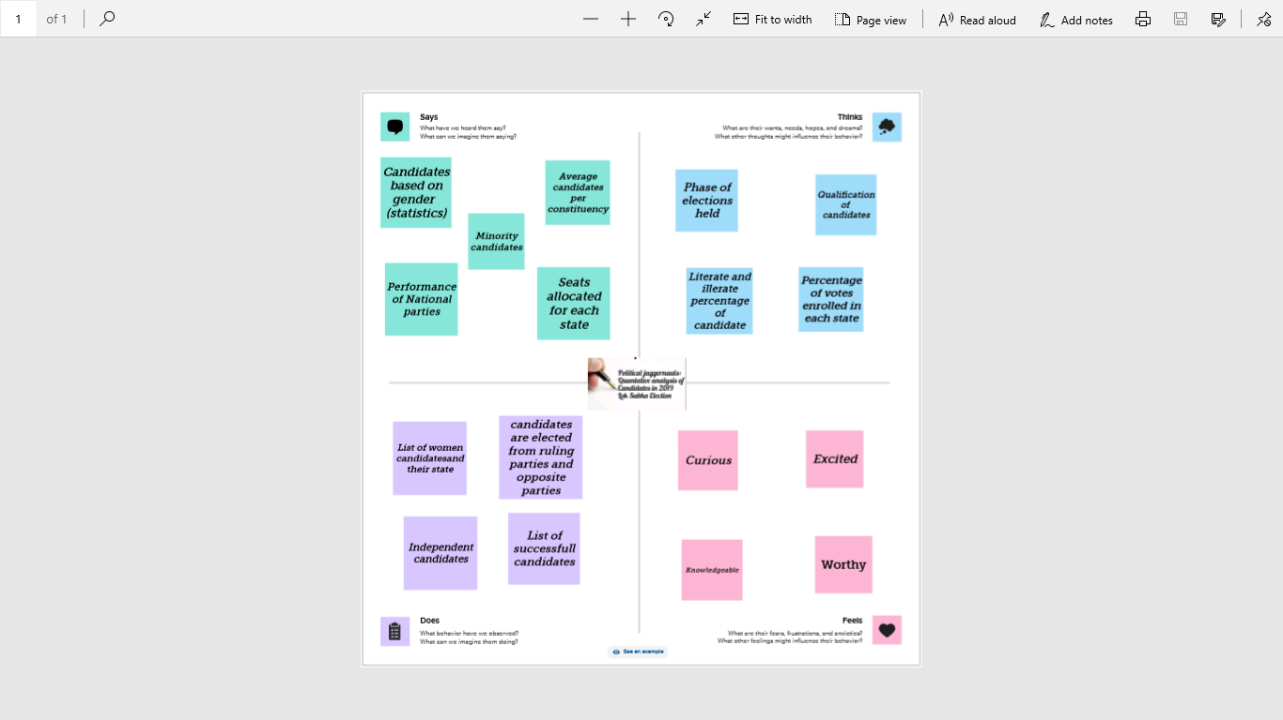

2.2 IDEATION AND BRAINSTORMING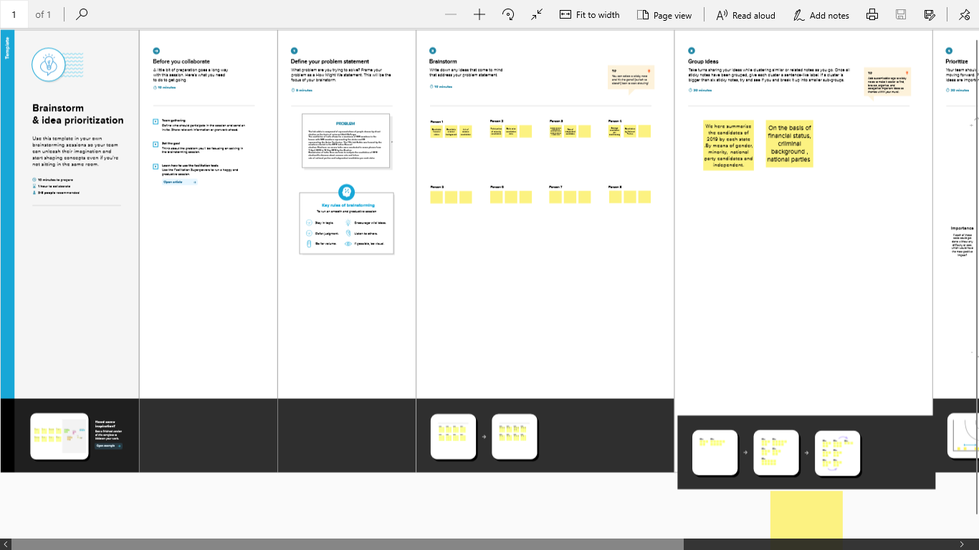

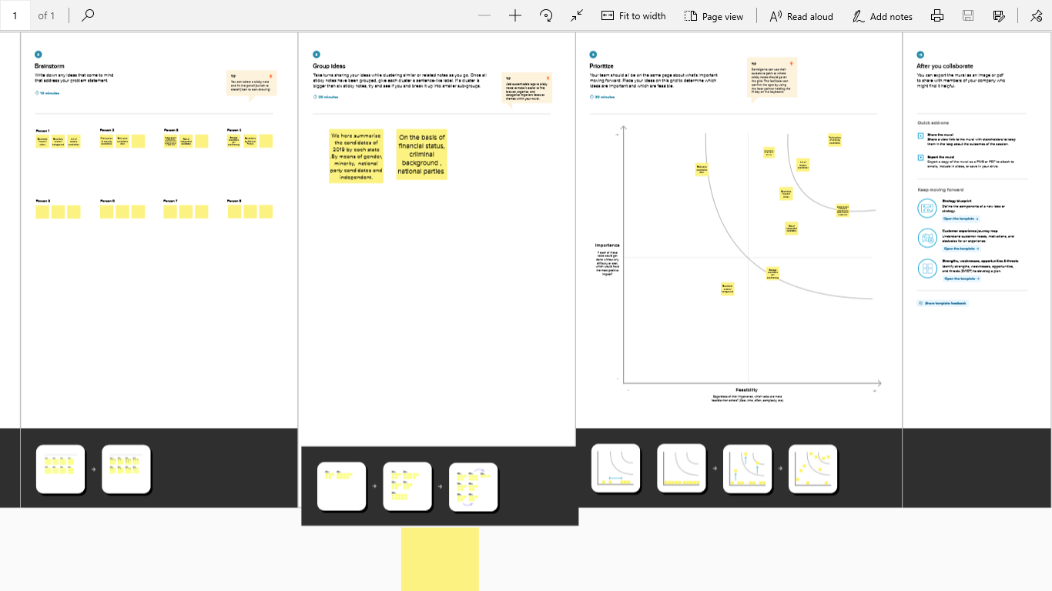

3.RESULT

GENERAL VOTES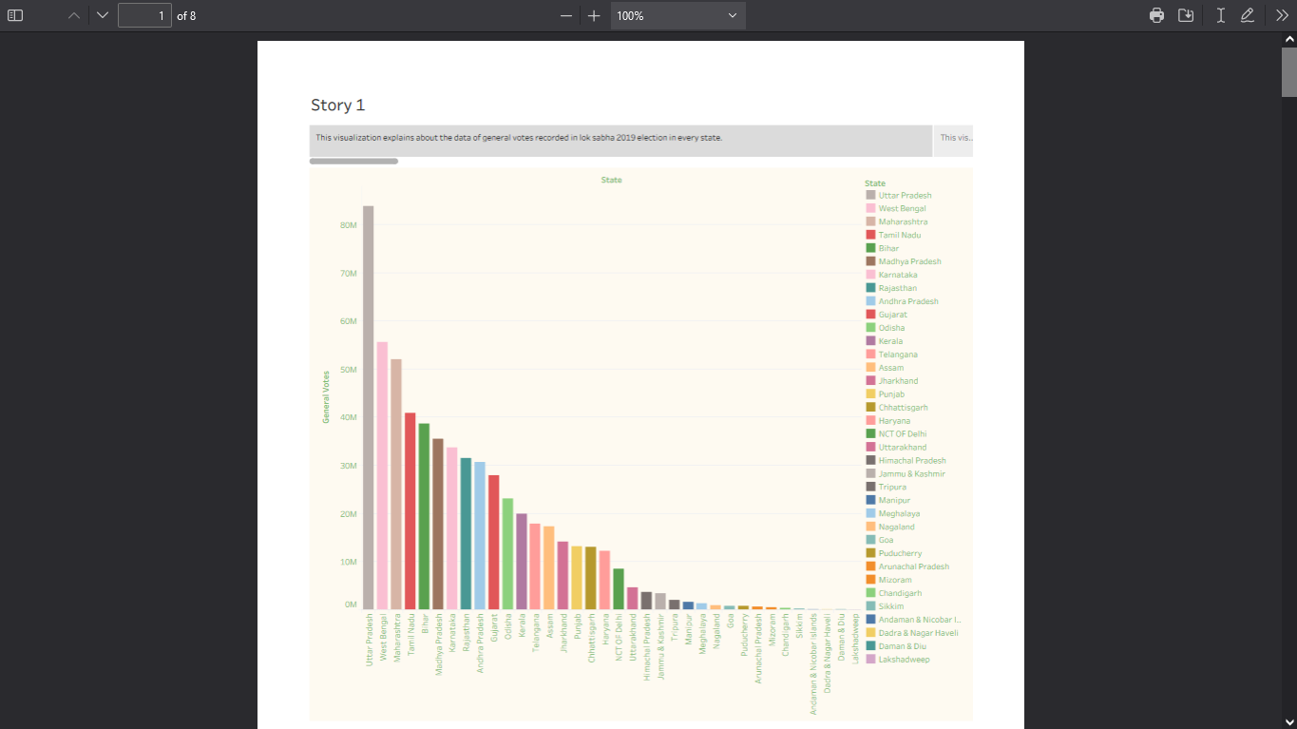

WINNING CANDIDATES 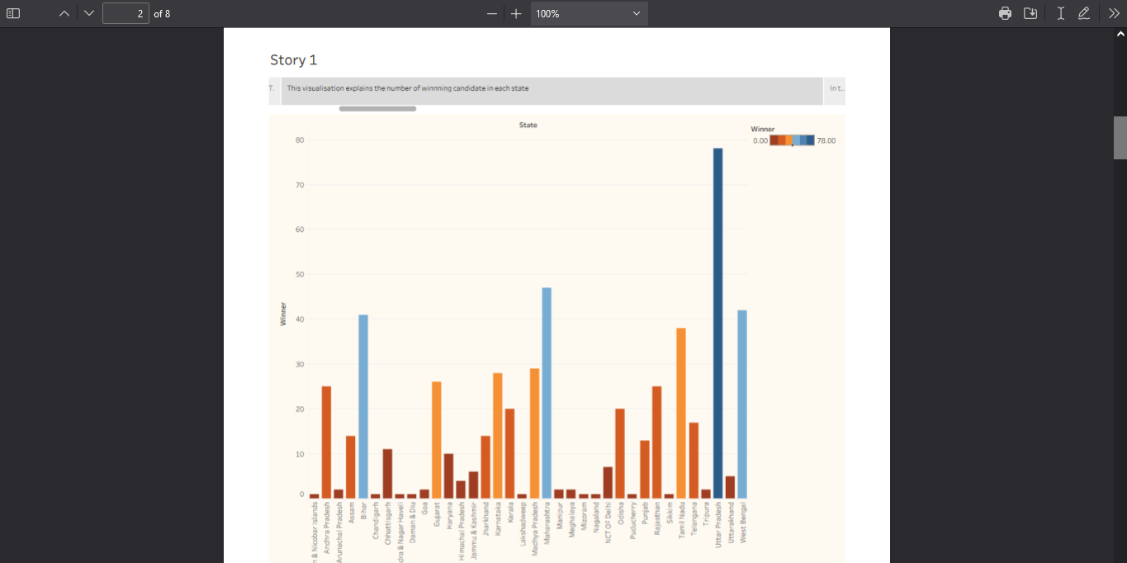

AGE WISE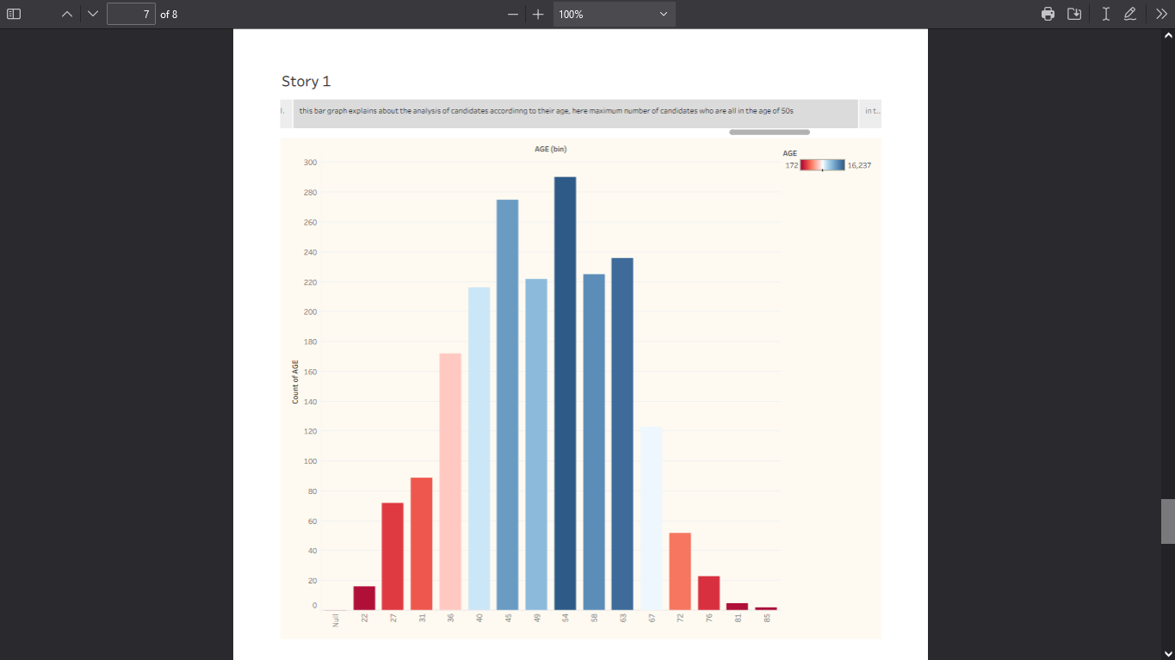

CATEGORY WISE EACH PARTY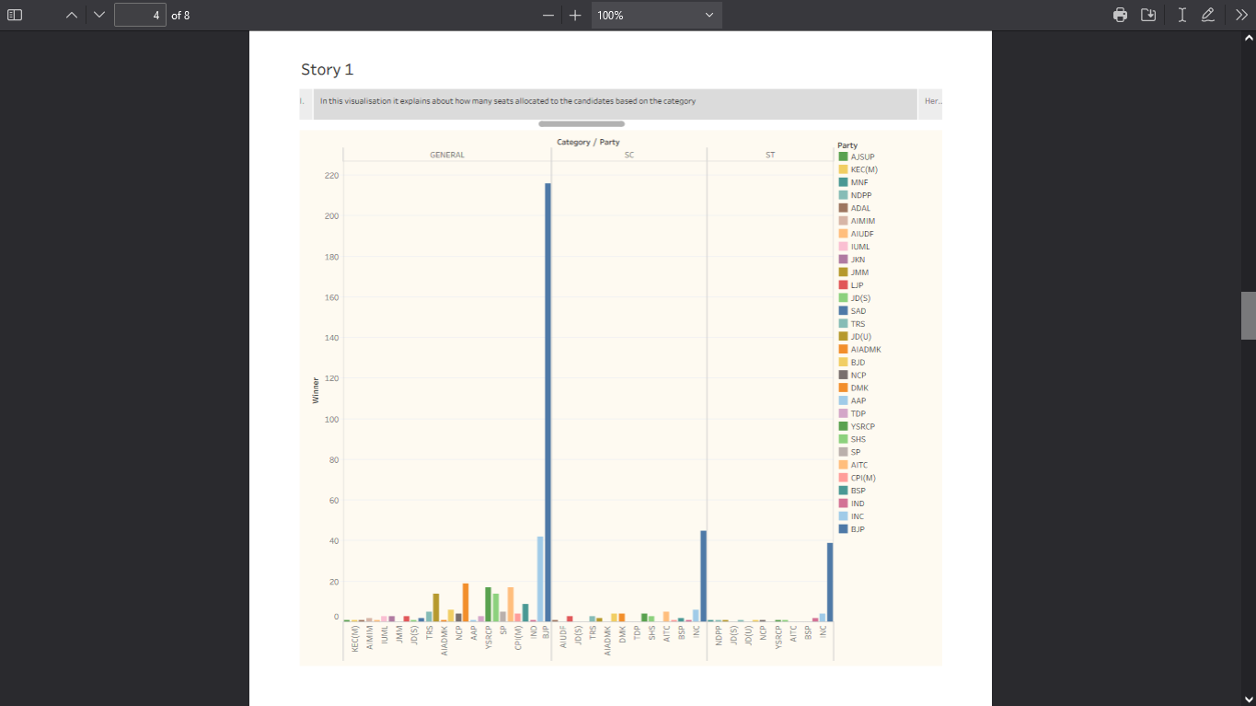

CRIMINAL RECORDS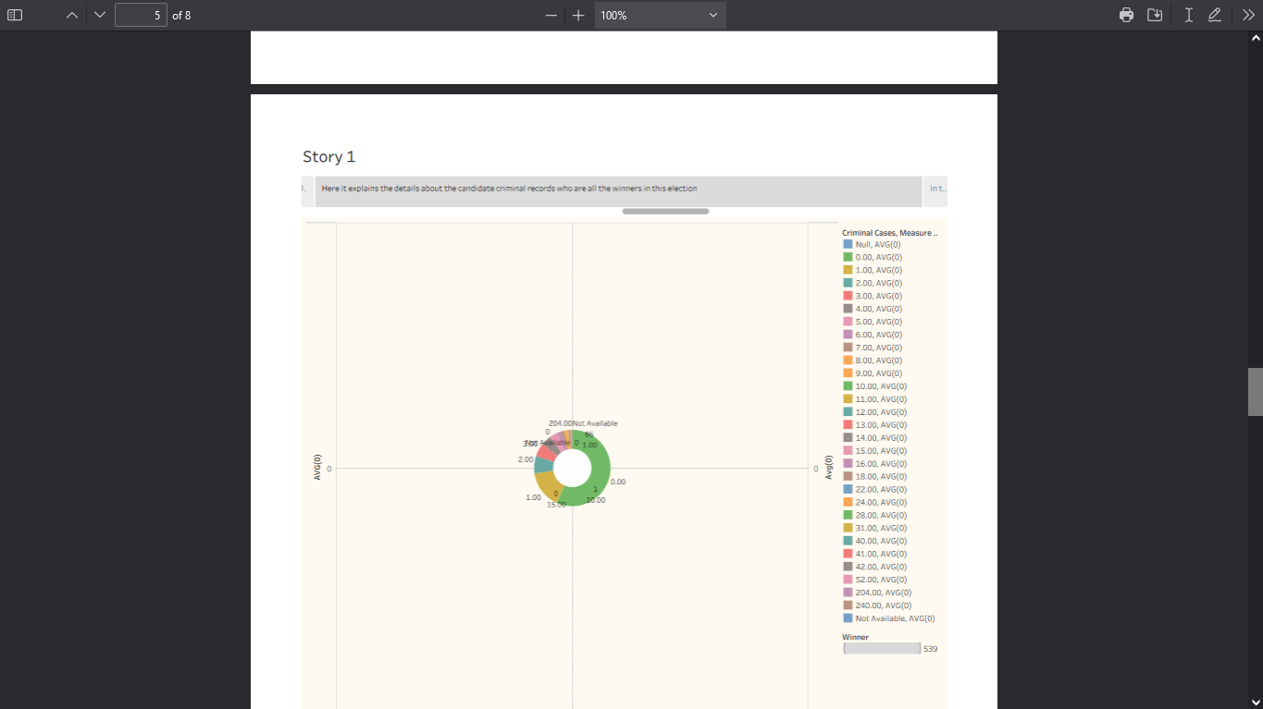

ELECTORS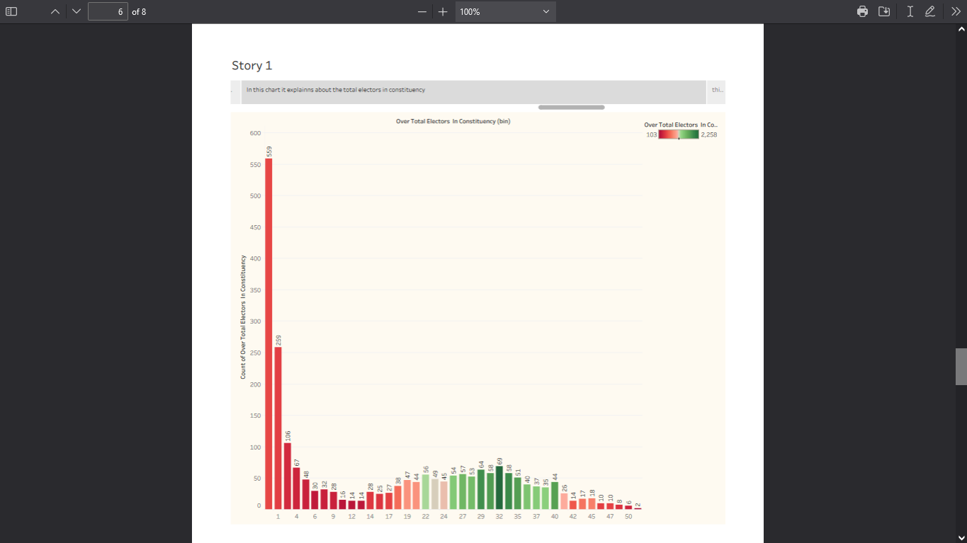

WINNING SEATS BY EACH PARTY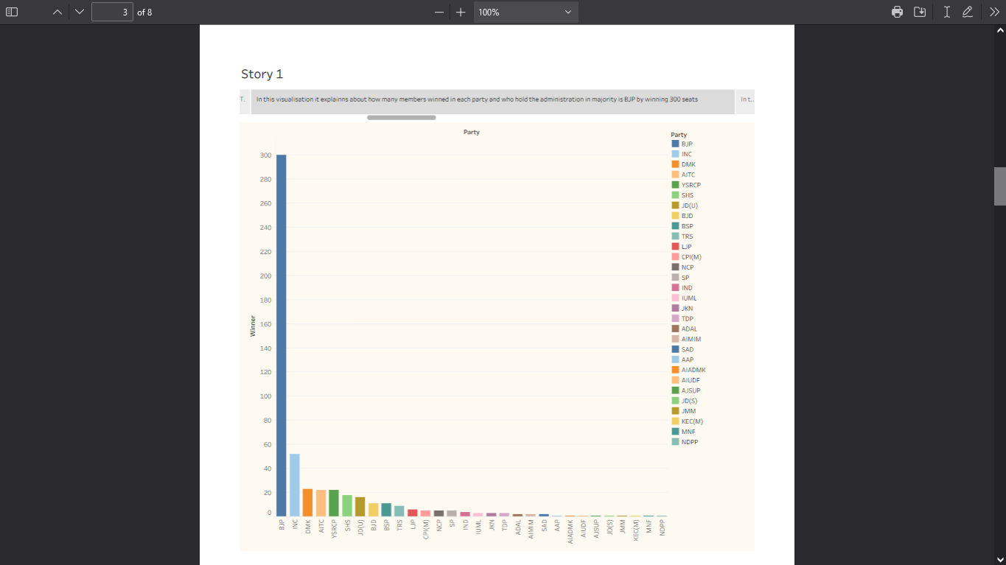

DASHBOARD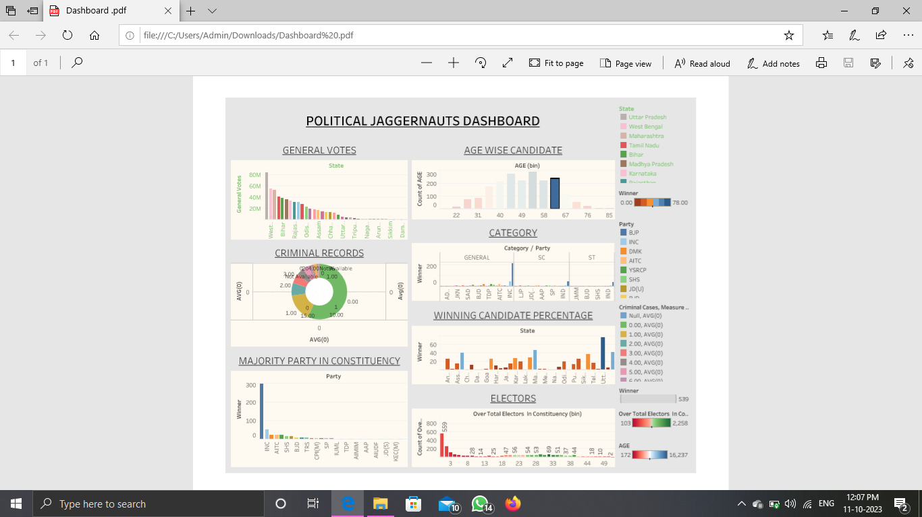

4.ADVANTAGES AND DISADVANTAGES

* Advantages
* **Participate in data culture** – become conversant with data scientists, and data analysts, and be a data steward for the data you know best.
* **Become a better communicator** – create compelling, convincing narratives with data storytelling and supporting your reports and presentation with data visualizations.
* **Build marketable skills** – as you develop your data literacy and master new tools, you increase your value as an employee.
* **Empowered business leaders** – dashboards and data analysis skills help decision makers act faster without relying on IT to process data for them.
* Disadvantages
* **Limited data preprocessing** – Tableau Desktop allows you do to very basic preprocessing. This includes joining and blending data.
* **Scheduling or notification of reports** – Tableau does not provide the feature of automatic refreshing of the reports with the help of scheduling.

5.APPLICATION

Tableau public, Mural, Github

6.CONCLUSION

By this presentataion we anlaysis the datas of candidates who are all participated in the

7.FUTURE SCOOP

Data literacy refers to the ability to read, understand, analyse and communicate with data, which enables individuals and organizations to make informed decisions, drive innovation, and achieve success.

Data literacy will make candidates more attractive and allow those with this skillset to excel with any employer.

VIDEO DEMOSTRATION

Link: https://youtube.com/watch?v=aWbLbamiHNo&si=0ZD6EfUic5HhYQs8